|  |
| --- |
| Nanyang Polytechnic   Centre for IT Innovation  User Guide  For  Sea Transportation E Portal Services (STEPS)  Android and iPhone  (Administrator)  Version 0.1 |

@ Copyright Nanyang Polytechnic 2020

This copyright in this work belongs to Nanyang Polytechnic. The information contained in this work is confidential and must not be reproduced or disclosed to others without the prior written permission of Nanyang Polytechnic.

**DOCUMENT CONTROL**

|  |  |  |  |
| --- | --- | --- | --- |
| **Version** | **Date** | **Prepared By** | **Changes from Previous Version** |
| 0.1 | 08-Sep-2020 | Nicholas Tan | First Draft |

Table of Contents

1 Purpose 5

2 Getting Started 5

3 User Role 5

3.1 Administrator 5

4 FUNCTIONAL GUIDE 6

4.1 Login 6

4.2 Forgot Password 7

4.3 2 Factor Authentication 8

4.4 Manage Account 9

*4.4.1* View Profile 9

*4.4.2* Change Password 10

*4.4.3* Logout 11

4.5 Manage Pending Requests 12

*4.5.1* View All Requests Pending Approval 12

*4.5.2* View Ad-Hoc Requests Pending Approval 13

*4.5.3* View Out-Of-Schedule Requests Pending Approval 14

*4.5.4* Approve Request 15

*4.5.5* Approve Recurring Request 15

*4.5.6* Reject Request 16

*4.5.7* Reject Recurring Requests 17

4.6 Manage Bookings 18

*4.6.1* View Bookings 18

*4.6.2* Search Bookings 19

*4.6.3* View Bookings in Calendar Mode 21

*4.6.4* Advanced Filter Booking 22

*4.6.5* Make Ad-Hoc Passenger Bookings 25

*4.6.6* Make Ad-Hoc RPL Bookings 28

*4.6.7* Cancel Approved Bookings (This booking only) 29

*4.6.8* Cancel Approved Bookings (For future bookings) 31

4.7 Notifications 32

*4.7.1* View Notifications 32

*4.7.2* Filter Notifications 32

4.8 Announcements 33

*4.8.1* View Announcements 33

*4.8.2* Delete Announcements 33

# Purpose

This document provides step by step instructions on the features provided by Sea Transportation E Portal Services (STEPS) – Android and iPhone, for the Administrator.

# Getting Started

To start using STEPS – Android and iPhone:

* Download the STEPS.apk from <https://callyng.github.io/Push/index.html>.
* For Android:
  + Enable Chrome to install apps from external sources in settings.
  + Install the STEPS app through the apk file.
  + Click “INSTALL ANYWAY” when it is blocked by play protect.
  + Click “OPEN” when app is installed successfully.

# User Role

For the mobile app, there will be 5 user roles, but this guide will only be for the Administrator.

## Administrator

Administrator is the key user of this mobile app. He/she has the “super user” access to STEPS. Administrator can access the following functions:

* Login
* Forgot Password
* 2 Factor Authentication
* Manage Account
* Manage Pending Requests
* Manage Bookings

# FUNCTIONAL GUIDE

## Login

Step 1: In the ***Username*** or ***Email*** textbox (Figure 4.1.1), enter your username or email.

Step 2: In the ***Password*** textbox, enter your password.

Step 3: Click on the ***Login*** button.

Step 4: After Logging in, they will be directed to the ***Home Page*** (Figure 4.1.2) or the ***OTP Page*** that will require you to login via 2 factor authentication (4.3).

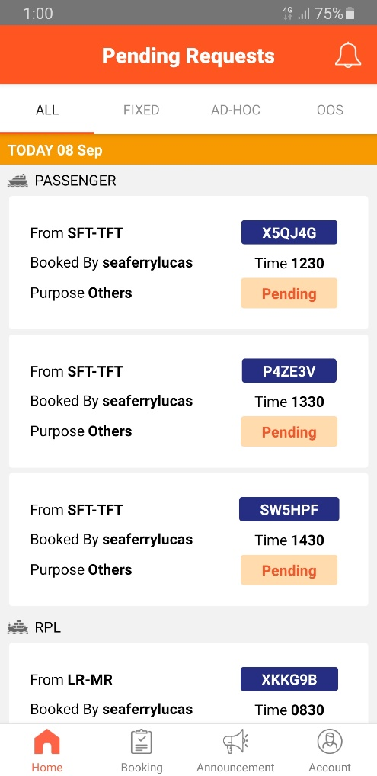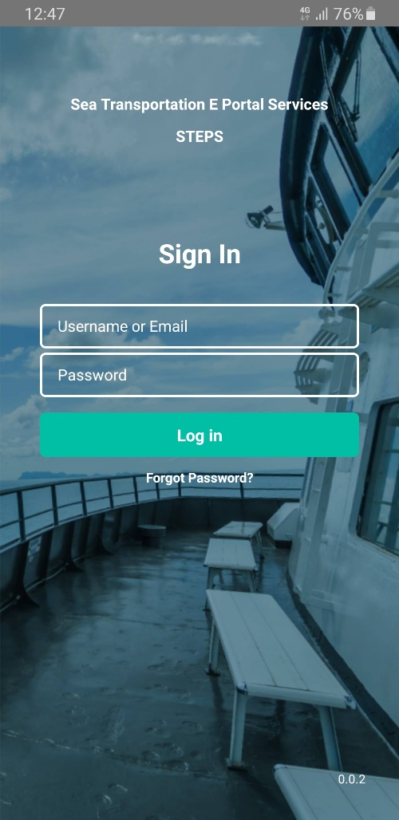

Figure 4.1.2: Home Page

Figure 4.1.1: Login Page

## Forgot Password

Step 1: On the ***Login*** page (Figure 4.1.1), click on ***Forget Password*** button.

Step 2: The ***Forgot Password Page*** will then appear (Figure 4.2.1).

Step 3: In the ***Username or Email*** textbox, enter your username or email address.

Step 4: Click on the ***Send Verification Code to Email*** button (Figure 4.2.1).

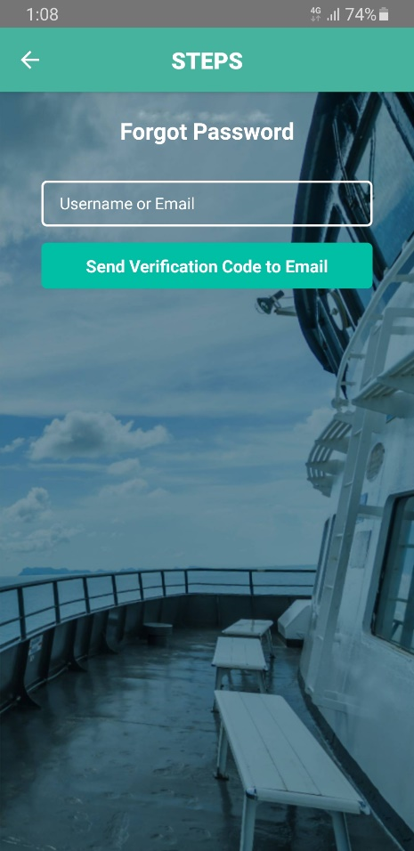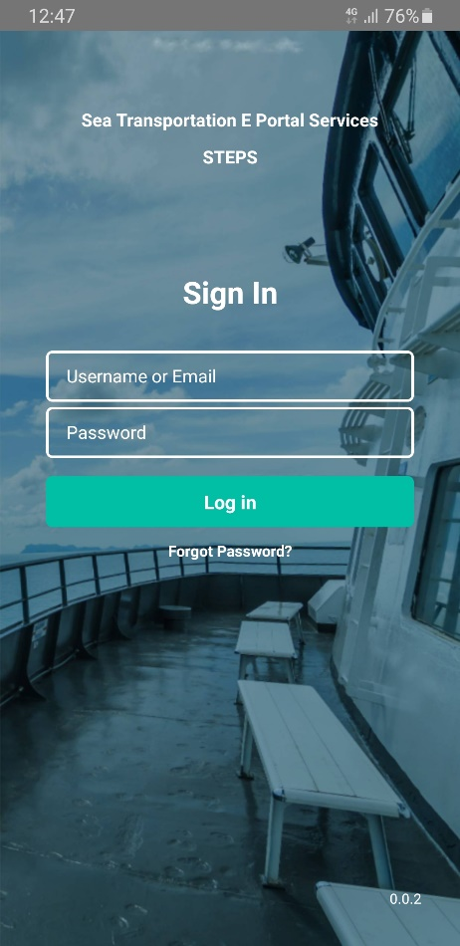

Figure 4.2.1: Forgot Password Page

Figure 4.1.1: Login Page

## 2 Factor Authentication

Step 1: After logging in, the ***OTP Page*** will be displayed (Figure 4.3.1). You will then receive an email with the required 6 digits code you will need to enter to verify your identity.

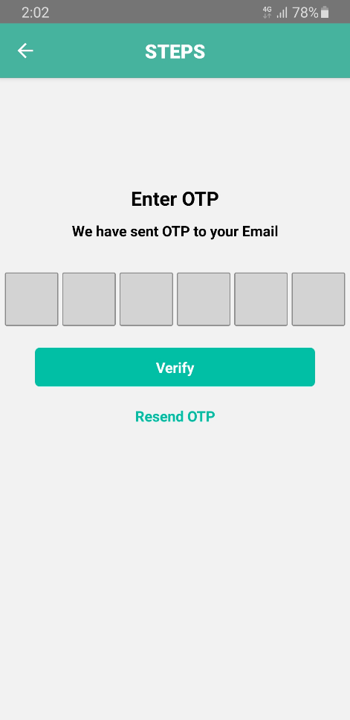Step 2: After entering the required 6 digits code (Figure 4.3.2), click on the ***Verify*** button to finish the login process or the ***Resend OTP*** button to resend the 6 digits code if you did not receive it in your email.

Figure 4.3.1: OTP Page

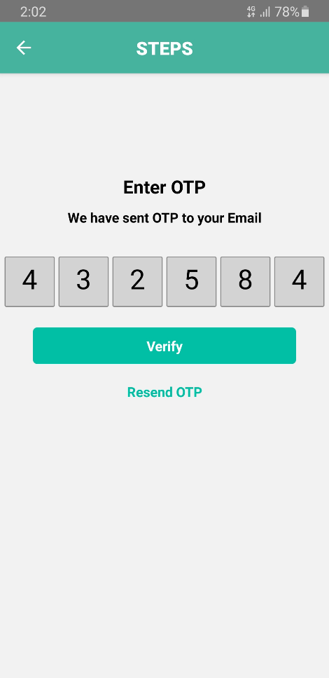

Figure 4.3.2: OTP Page With OTP

## Manage Account

Account contains information such as your **Name**, **Username** and **Email**.

### View Profile

Step 1: Click on the ***Account*** button on the bottom navigation bar to access the ***Account Page*** (Figure 4.4.1.1).

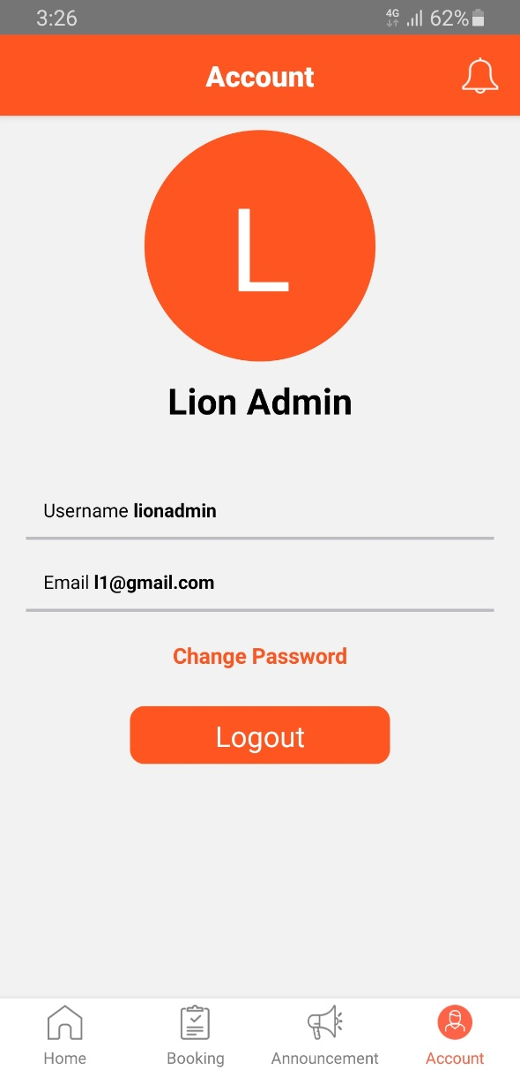

Figure 4.4.1.1: Account Page

### Change Password

Step 1: In the ***Account Page*** (Figure 4.4.1.1), click on ***Change Password*** button.

Step 2: The ***Change Password page*** will then appear (Figure 4.4.2.1).

Step 3: In the 3 textboxes of the ***Change Password Page***, enter in your ***Current Password***, ***New Password*** and ***Confirm New Password***.

**Note**: Password needs to contain at least 1 uppercase, 1 lowercase, and at least 8 characters.)

Step 4: Next, click on the ***Change*** button to finish changing to your new password.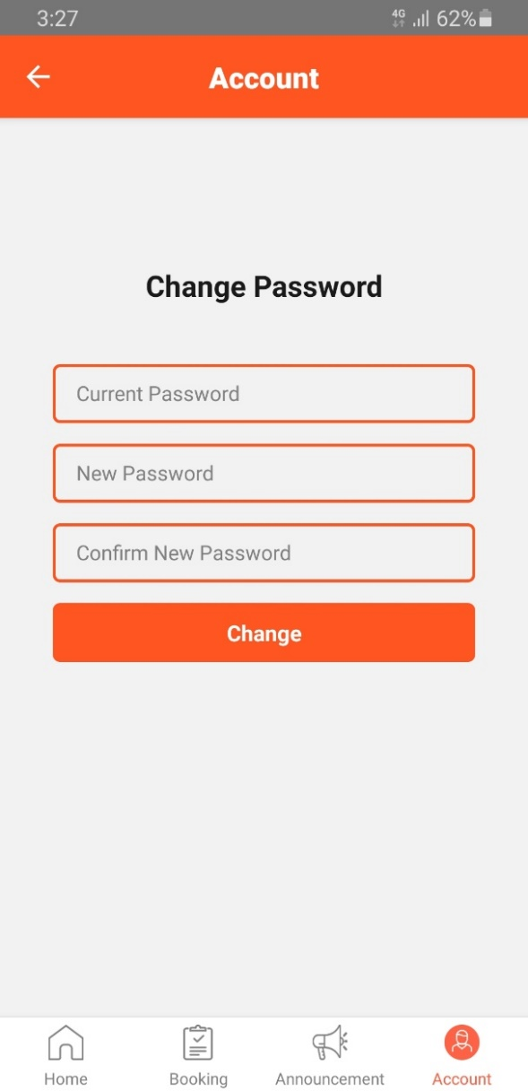

Figure 4.4.1.1: Account Page

Figure 4.4.2.1: Change Password Page



### Logout

On the ***Account Page***, click on ***Logout*** to logout of the system (Figure 4.4.1.1).



Figure 4.4.1.1: Account Page

## Manage Pending Requests

For each of the booking requests, it displays the from-to destination, time, purpose, booking code, SAF unit.

### View All Requests Pending Approval

There are 2 types of requests (Ad-Hoc and Out-Of-Scheduled) that is displayed in the ***Home Page*** of the mobile application (Figure 4.1.2).

This page shows all the Pending Requests on the app to the administrator and they are grouped by date so that he/she can approve or reject the requests.

Step 1: By clicking on a ***Request***, it shows the ***Request Information*** (Figure 4.5.1.1).

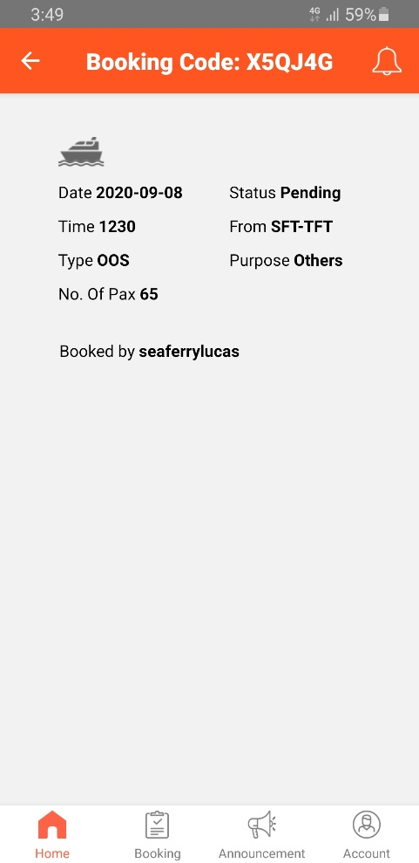

Figure 4.5.1.1: Request Info

Figure 4.1.2: Home Page

### View Ad-Hoc Requests Pending Approval

By clicking on the ***AD-HOC*** text on the top of the page, it shows all the Ad-Hoc pending requests grouped by date (Figure 4.5.2.1).

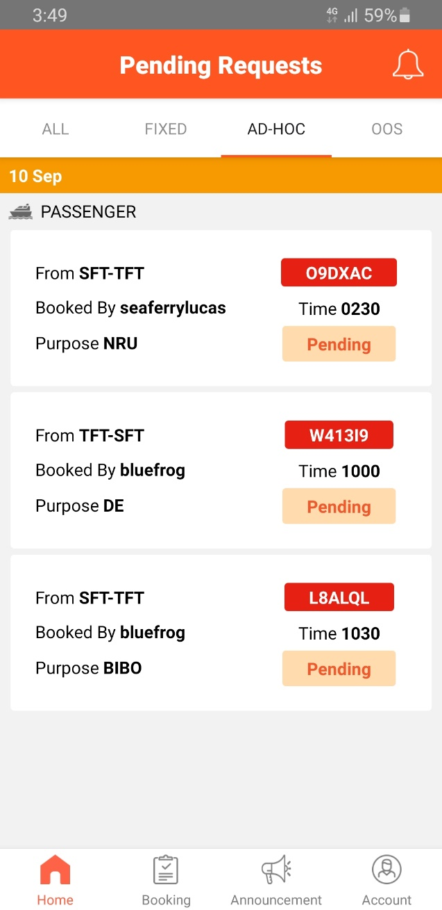

Figure 4.5.2.1: Ad-Hoc Request

### View Out-Of-Schedule Requests Pending Approval

By clicking on the ***OOS*** text on the top of the page, it shows all the Out-Of-Scheduled (OOS) pending requests grouped by date (Figure 4.5.3.1).

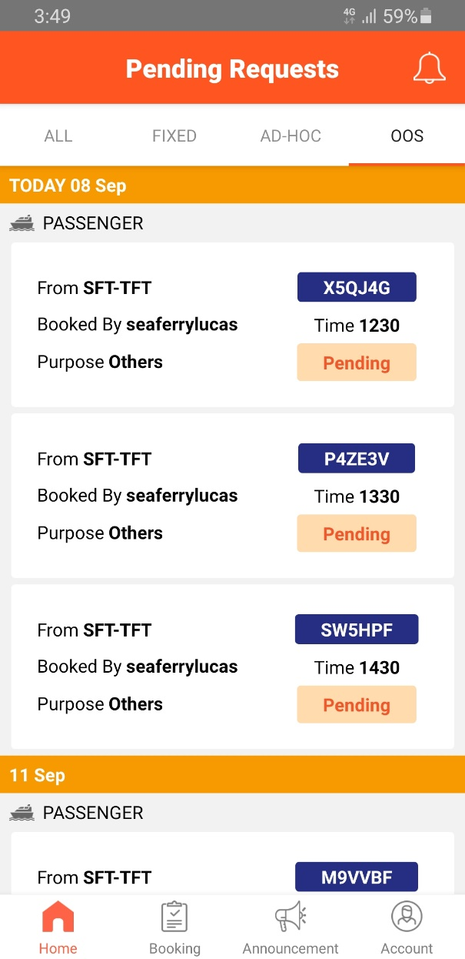

Figure 4.5.3.1: OOS Request

### Approve Request

Administrator can approve the pending requests so that a push notification can be sent to the unit notifying them of the approval.

Step 1: Swap left on the ***Pending Request*** (Figure 4.1.2) to show a select button (Figure 4.4.4.1).

Step 2: Click on the approve button (***Green Tick***) to approve the request (Figure 4.5.4.1).

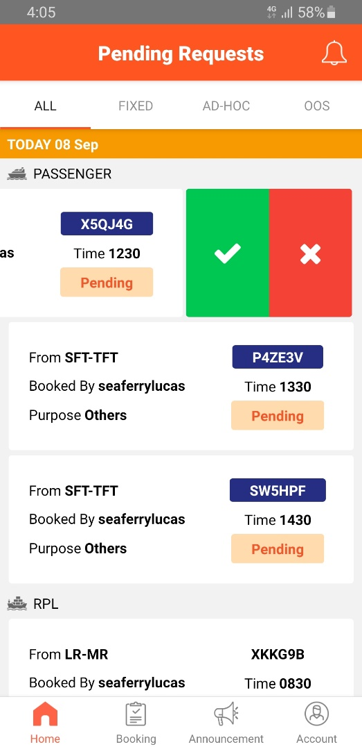

Figure 4.5.4.1: Approve/Reject Request

Figure 4.1.2: Home Page

### Approve Recurring Request

Follow the same steps in ***4.5.4***.

### Reject Request

Similarly, to approving requests (***4.5.4***), the administrator can reject the pending requests so that a push notification can be sent to the unit notifying them of the rejection with reason.

Step 1: Swap left on the ***Pending Request*** (Figure 4.1.2) to show a select button (Figure 4.5.4.1).

Step 2: Click on the reject button (***Red Cross***) to reject the request (Figure 4.5.4.1).

Step 3: After clicking on the reject button, the reason for rejection page will be displayed (Figure 4.5.5.1).

Step 4: Enter a valid reason in the ***Add Reason*** text field and then click on the ***Submit*** button to reject the request.



Figure 4.5.4.1: Approve/Reject Request

Figure 4.1.2: Home Page

Reason for rejection page displayed (Figure 4.5.6.1).

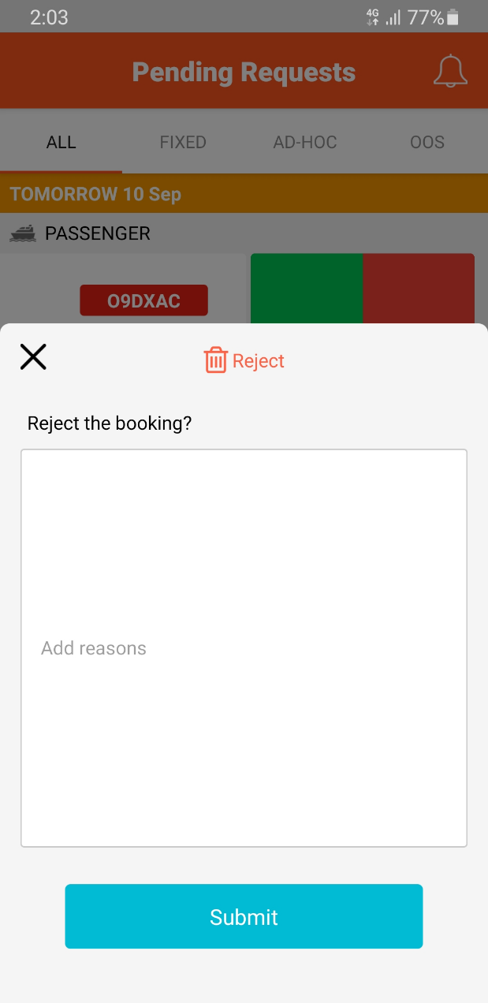

Figure 4.5.6.1: Reason for Rejection Page

### Reject Recurring Requests

Follow the same steps in step ***4.5.6***.

## Manage Bookings

### View Bookings

By clicking on the ***Booking*** page on the ***bottom navigation bar***, the ***Booking Page*** will be displayed (Figure 4.6.1.1). The ***Booking Page*** shows the list of bookings in calendar view so that the administrator can see the bookings they have each day.

Today’s date will be selected by default.

Step 1: Clicking on a ***Booking*** will show the ***booking information*** (Figure 4.6.1.2).

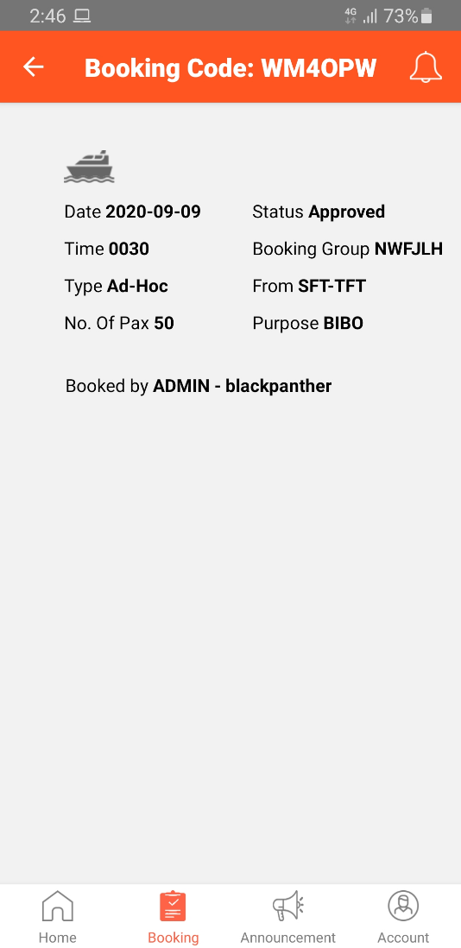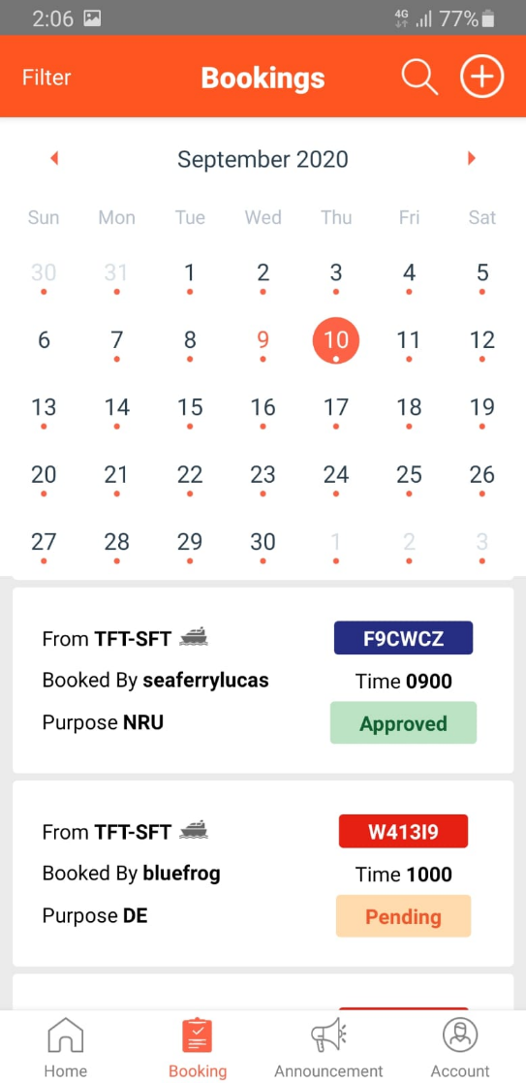

Figure 4.6.1.2.: Booking Information

Figure 4.6.1.1: Booking Page

### Search Bookings

Step 1: Click on the ***magnifying glass icon*** on the top of the booking page (Figure 4.6.1.1) to display the ***Search Page*** (Figure 4.6.2.1).

Step 2: Search for the booking you want to search in the ***search bar*** by entering the booking code or group.

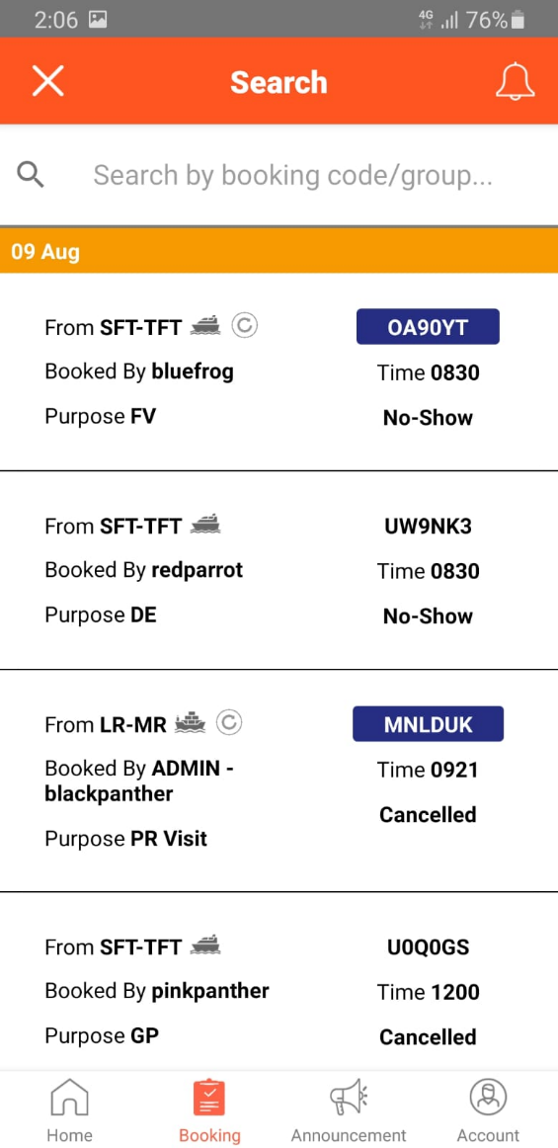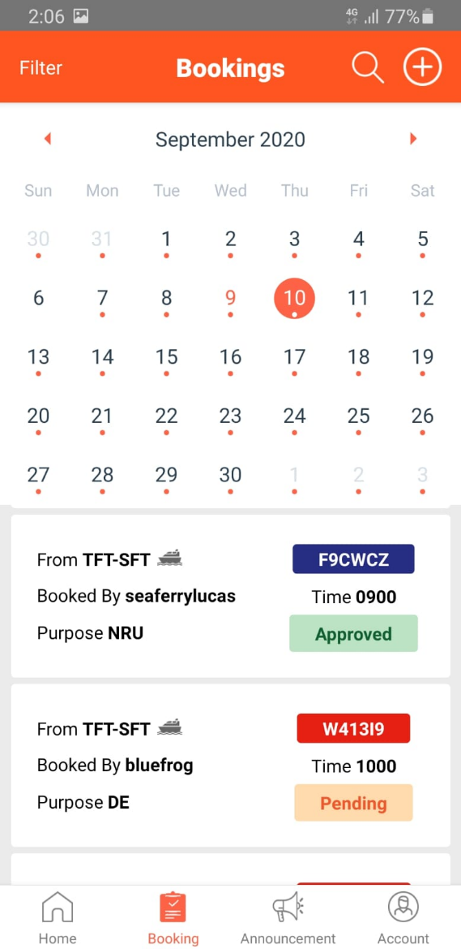

Figure 4.6.2.1: Search Page

Figure 4.6.1.1: Booking Page

Step 3: The booking list will show the relevant bookings based on the search text (Figure 4.6.2.2).

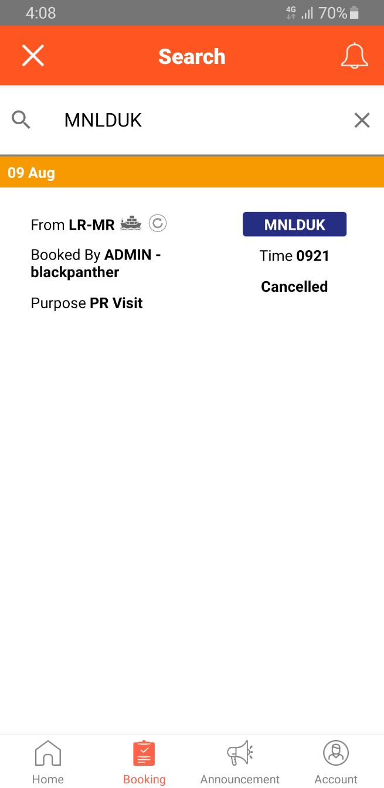

Figure 4.6.2.2: Search Page 2

### View Bookings in Calendar Mode

Test

### Advanced Filter Booking

Test

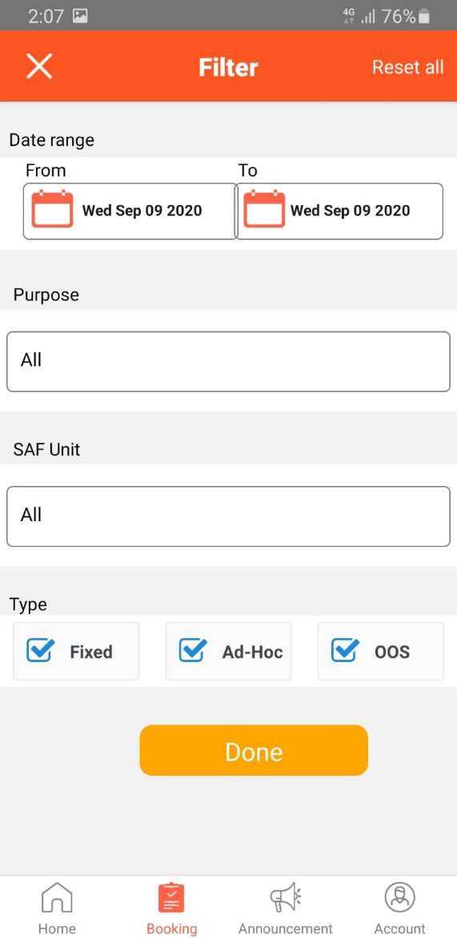

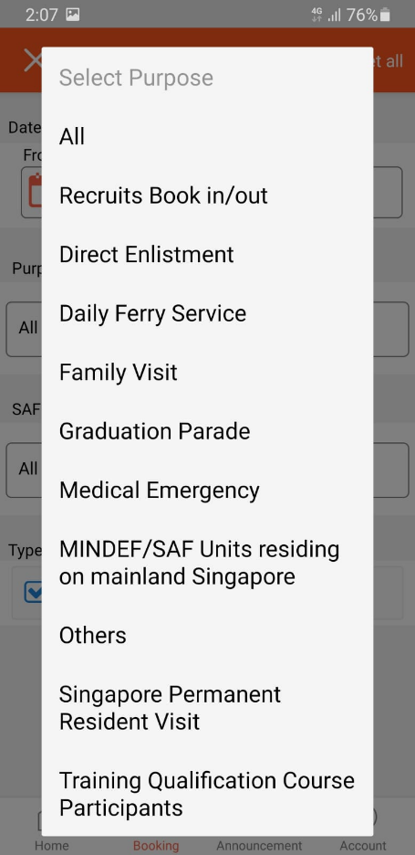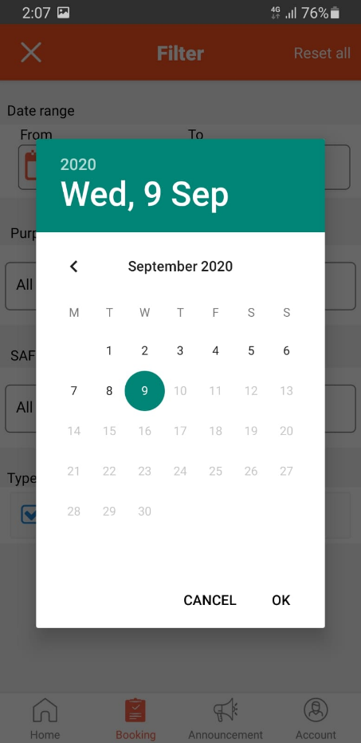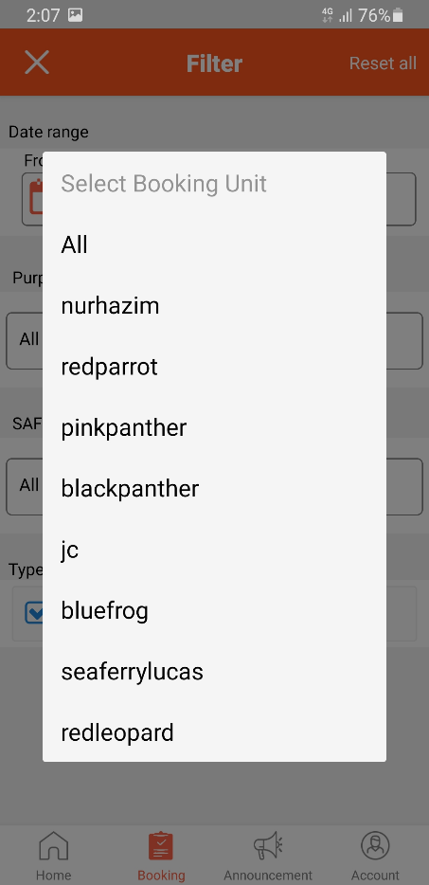

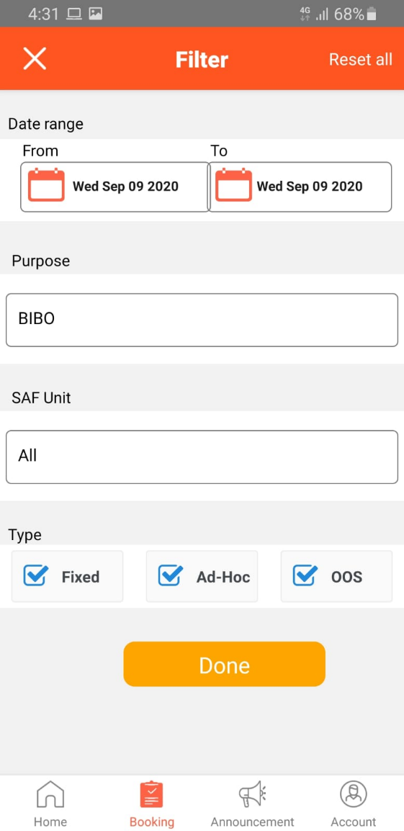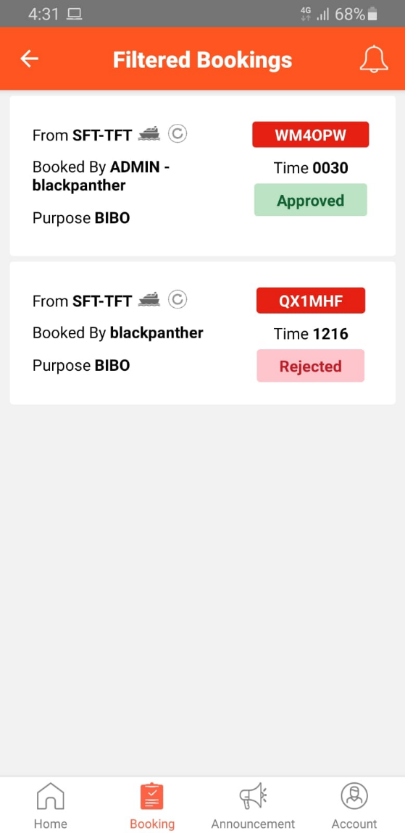

### Make Ad-Hoc Passenger Bookings

Test

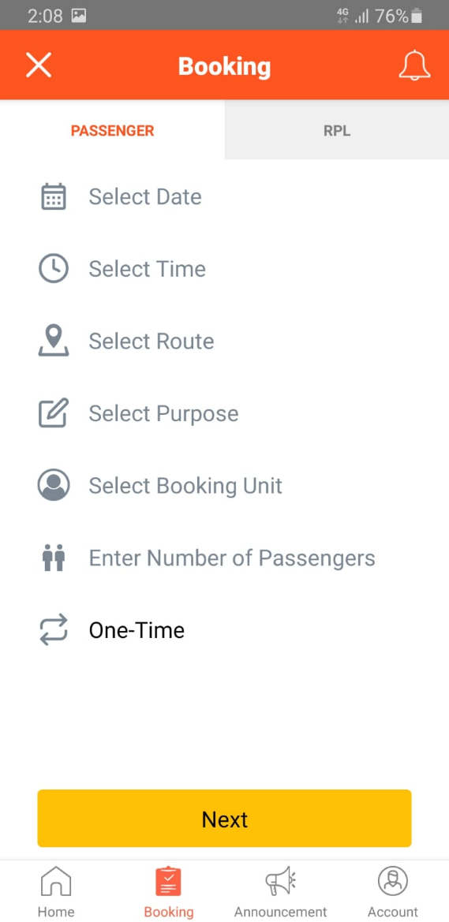

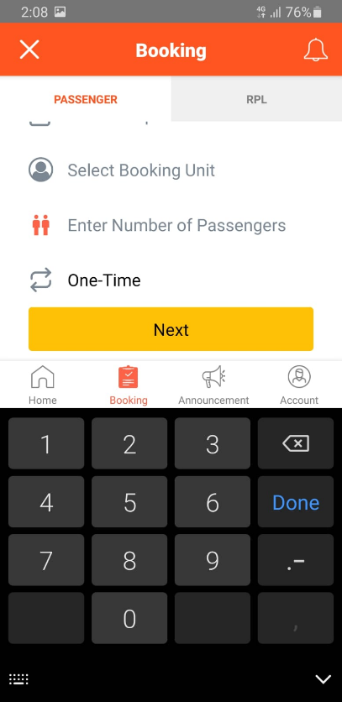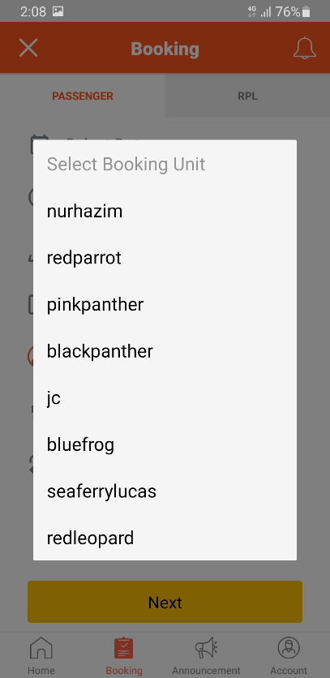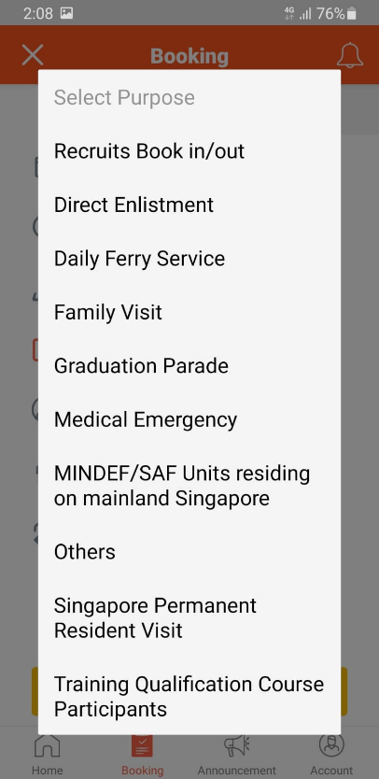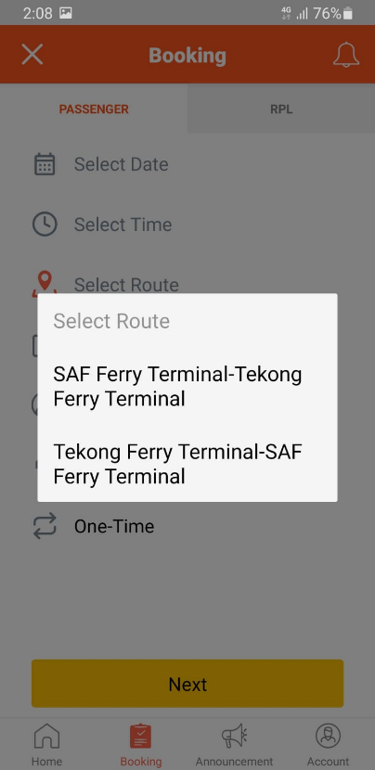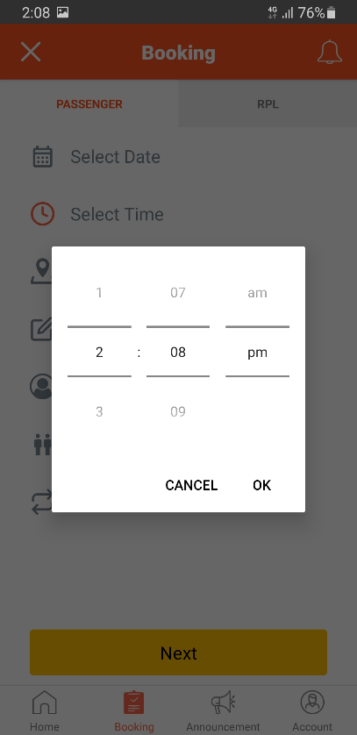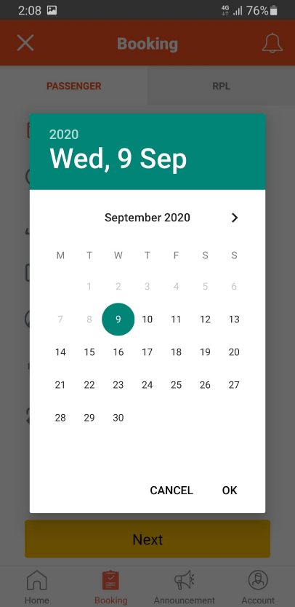

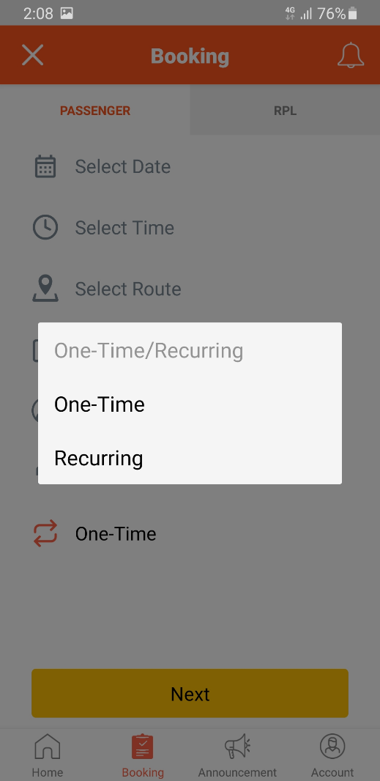

### Make Ad-Hoc RPL Bookings

Test

### Cancel Approved Bookings (This booking only)

Step 1: Bookings can be cancelled by swing the booking to the left (Figure 4.6.1.1). The ***Cancel*** button will then be displayed next to the booking (Figure 4.6.7.1).

Step 2: Click on the ***Cancel*** button to display the page where the booking can be cancelled (Figure 4.6.7.2).



Figure 4.6.1.1: Booking Page

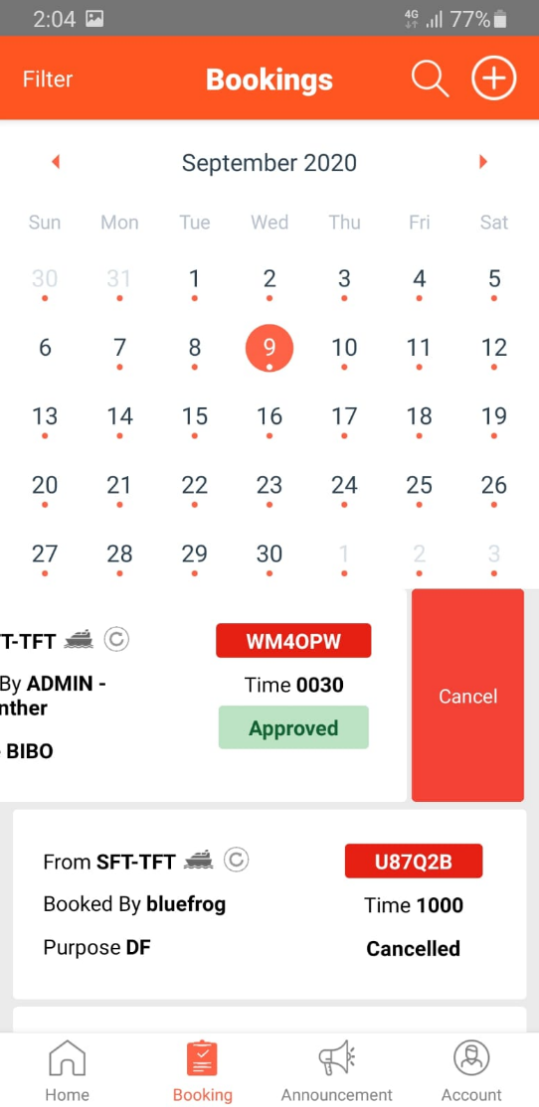

Figure 4.6.7.1: Cancel Approved Bookings

Step 3: Enter a valid reason in the ***Add reasons*** text field and check the ***This booking only*** checkbox (Figure 4.6.7.2).

Step 4: Click on the ***Submit*** button to cancel the booking.

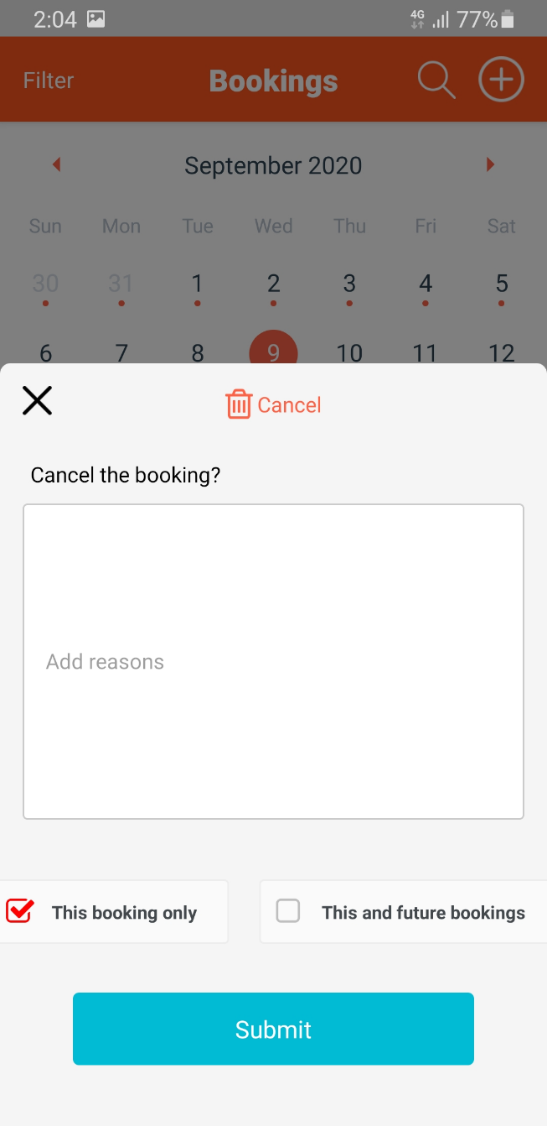

Figure 4.6.7.2: Reason for Cancelling Booking

### Cancel Approved Bookings (For future bookings)

Test

## Notifications

Test

### View Notifications

Test

### Filter Notifications

Test

## Announcements

Test

### View Announcements

Test

### Delete Announcements

Test

**END OF DOCUMENT**